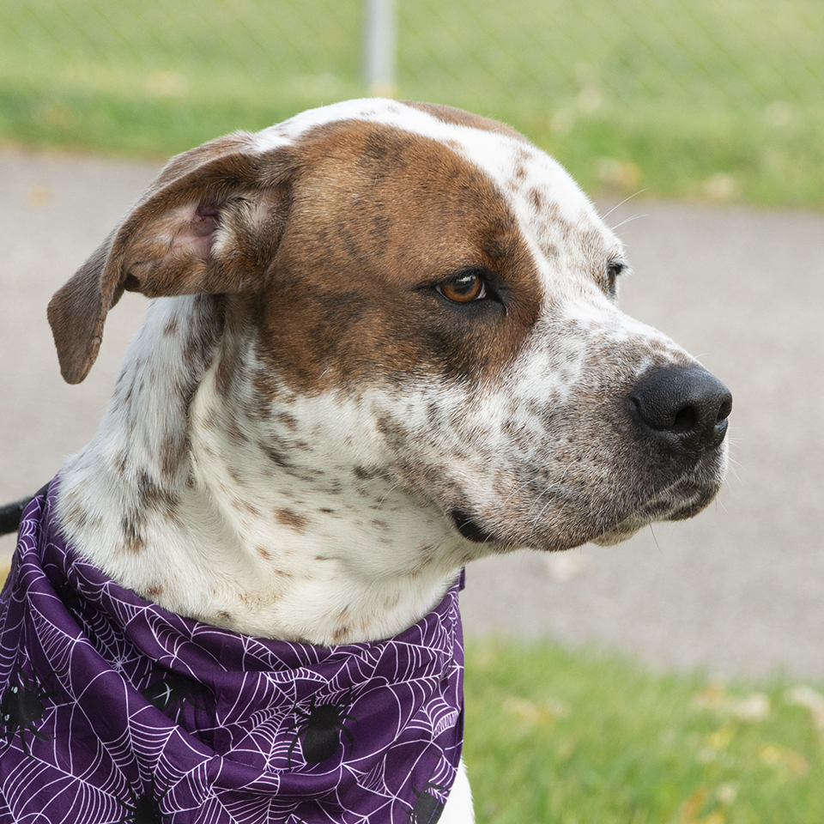
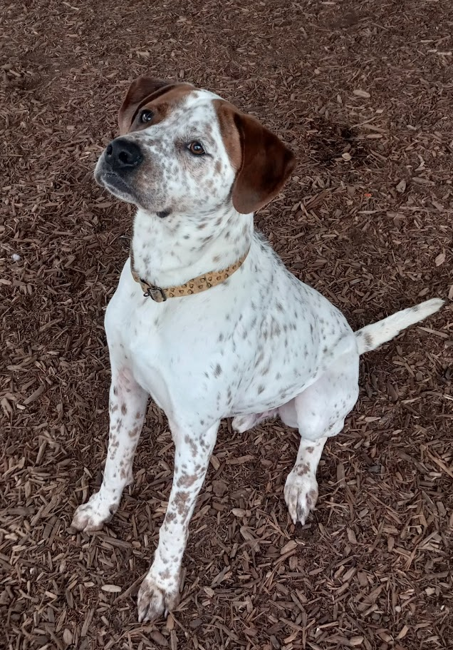
DALTON
*GSP and
possible lab mix

German Short-hair Pointer *
2 – 3yr young, fully vaccinated, Neutered male,
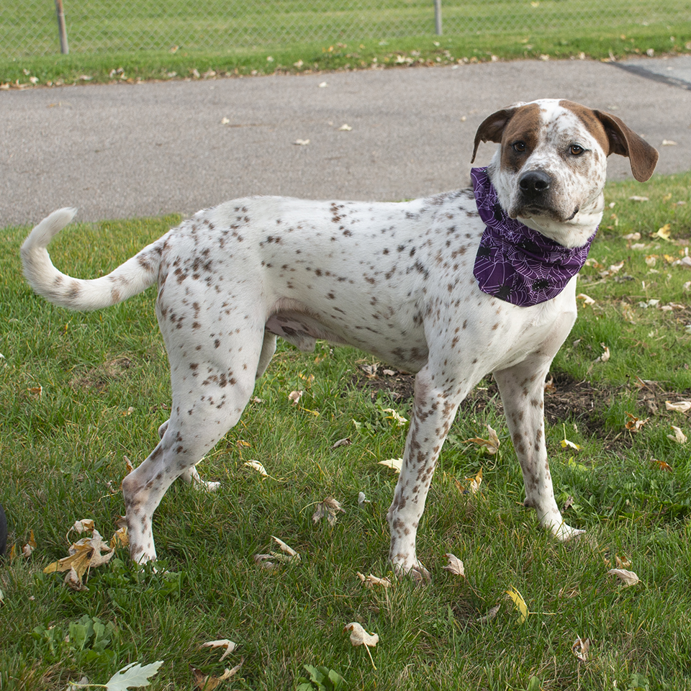
Approx 70lbs, crate trained, house trained
Very intelligent and enjoys his “training”
Friendly with adults & children
Prefers people and toys….over dogs
Learning to play “mannerly” w/other dogs
ENJOYS play time, walks, and exploring with his nose
Loves to chase whatever might run – TALL fenced yard required
Can entertain himself with a basket of toys
Loves the water (bath time and water bowls, maybe... pools/ponds too !)
Walks well on leash and is a perfect car rider


If interested in adopting DALTON….
Email PetsRRpassion@gmail.com
Dream4pets.org
Facebook.com/DreamPetRescue
petsRRpassion@gmail.com

