Buckeye !

* Approx 16 month
* Male, Lab / H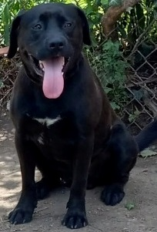ound mix
* Approx 65lbs
* Neutered & Vaccinated
* HW negative
* Very socialized w/dogs
* Good w/adults & children
* Loves water
* Walks well on leash
* House trained
* Crate trained
* Great on car rides
* **READY for ADOPTION**
* **Email** [**PetsRRpassion@gmail.com**](mailto:PetsRRpassion@gmail.com) **for application**

**ADOPTION application located on the ADOPTME page at Dream4pets.org**

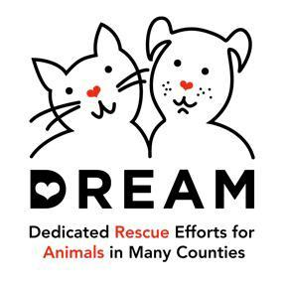

**Dream4pets.org**

Facebook.com/DreamPetRescuePetsRRpassion@gmail.com